|  |
| --- |
| OOP Lab: Assignment-02 |
| Armghan Ahmad |
| BSCS 2B |

Question 1:

#include<iostream>

using namespace std;

class Employee

{

public:

int employee_number;

string name;

int employee_phone_number[4];

int age;

float compensation;

Employee()

    {

employee_number=0;

age=0;

compensation=0;

employee_phone_number[0]=0;

    }

Employee(int employee_number,string name,int age,float *compensation*)

    {

this->age=age;

this->employee_number=employee_number;

this->name=name;

this->compensation=compensation;

    }

voidset_values()

        {

cout<<"Enter a Employee number"<<endl;cin>>employee_number;

cout<<"Enter a Employee name"<<endl;cin>>name;

cout<<"Enter a Employee phone number"<<endl;

for(inti=0; i<4; i++){

cin>>employee_phone_number[i];

        }

cout<<"Enter a compensation"<<endl;cin>>compensation;

cout<<"Enter a age"<<endl;cin>>age;

    }

voidget_func()

    {

this->employee_number=employee_number;

this->name=name;

this->compensation=compensation;

this->age=age;

    }

void print()

    {

cout<<employee_number<<endl;

cout<<name<<endl;

cout<<age<<endl;

cout<<compensation<<endl;

for(inti=0; i<4; i++)

        {

cout<<employee_phone_number[i]<<endl;

        }

    }

    ~Employee()

    {

cout<<"That's all"<<endl;

    }

};

int main()

{

    Employee E1(1,"akram",12,13);

for(inti=1; i<5; i++){

cout<<"Enter a "<<i<<" data here"<<endl;

    E1.set_values();

    E1.get_func();

E1.print();

    }

}

Output:

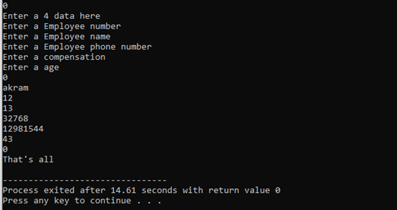

Question 2:

#include<iostream>

using namespace std;

class stringtype

{

        private:

        string first,second;

        int max1=0,max2=0;

        public:

        void set_value(string *s1*,string *s2*)

            {

        first=*s1*;

        second=*s2*;

            }

        void print_value()

            {

        cout<<"Value 1: "<<first<<endl;

        cout<<"Value 2: "<<second<<endl;

            }

        int maxlength()

            {

        for(int i=0; first[i] != '\0' ; i++){

                max1=max1+1;}

        for(int i=0; first[i] != '\0' ; i++){

                max2 = max2+1;}

        if (max2 >  max1)

                {

                return max2;

                }

        else

        return max1;

            }

        int compare()

            {

            int same=0;

            for(int i=0; i<max2; i++){

                if(first[i]=second[i])

                        {

                            same++;

                        }

                    }

            return same;

            }

};

int main()

{

stringtype s1;

s1.set_value("Armghan ","Aahmad");

s1.print_value();

cout<<s1.maxlength()<<endl;

cout<<s1.compare();

}

Output:



Question 3:

#include<iostream>

using namespace std;

class parent{

    public:

    parent(){

        cout<<"I am a parent. I got life"<<endl;

    }

    ~parent(){

        cout<<"I am a parent"<<endl;

    }

};

class child:public parent{

    public:

    child(){

        cout<<"I am a child. I got life"<<endl;

    }

    ~child(){

        cout<<"I am a child"<<endl;

    }

};

int main(){

    child c;

}

Output:

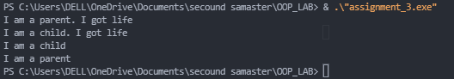

Question 4:

#include<iostream>

using namespace std;

class father{

    public:

    father(){

        cout<<"I am a father. "<<endl;

    }

    ~father(){

        cout<<"I am a father destructor"<<endl;

    }

};

class mother{

    public:

    mother(){

        cout<<"I am a mother. "<<endl;

    }

    ~mother(){

        cout<<"I am a mother destructor"<<endl;

    }

};

class child:public father,public mother{

    public:

    child(){

        cout<<"I am a child. "<<endl;

    }

    ~child(){

        cout<<"I am a child destructor"<<endl;

    }

};

int main(){

    father f;

    mother m;

    child c;

}

Output:

